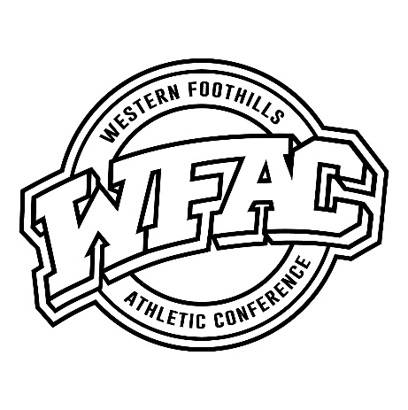
Western Foothills
Athletic Conference
East Lincoln Fred T. Foard Hickory North Iredell
North Lincoln Statesville St. Stephens West Iredell

2022 Softball Post Season Results & Awards
Release Date:
Final Team Standings: Overall Rec. Conf. Rec.
- East Lincoln 19-0 14-0
- North Lincoln 17-7 11-3
- St. Stephens 14-7 10-4
- Foard 9-10 9-5
- North Iredell 7-13 5-9
6 Hickory 6-17 4-10
7 West Iredell 3-14 3-11
8 Statesville 0-15 0-14
Conference Champion: East Lincoln Lady Mustangs
All Conference Selections:
East Lincoln: Leah Correll; Taliyah Thomas; Betsy Eatmon; Taniyah Thomas; Tatum Martin;
Madison Currence
Hickory: Abby Puett

St. Stephens: Mayson Lail; Anicka McFarland; Brylyn McFarland; Shelby Dale;
Chloe Henline
Fred T. Foard: Riley Vogel; Kaitlyn Leonhardt; Alyssa Smith; Aly Punch; Sarah Leonhardt

North Iredell: Martha Parlier; Maicie Earnest
Statesville: Te’Hanna Morrison

North Lincoln: Lilly Stump; Tessa Hunt; Clara Grace Dellinger; Ellie Huss; Skyla Morrison
Aubrie Cada
West Iredell: Kaylee Chapman
Pitcher of The Year: Players of The Year:
Mayson Lail - St. Stephens Riley Vogel - Foard / Lilly Stump - North Lincoln
Coach of The Year:
Breanna Tapp - North Lincoln
Mustangs Tigers Red Tornadoes Raiders Knights Greyhounds Indians Warriors

